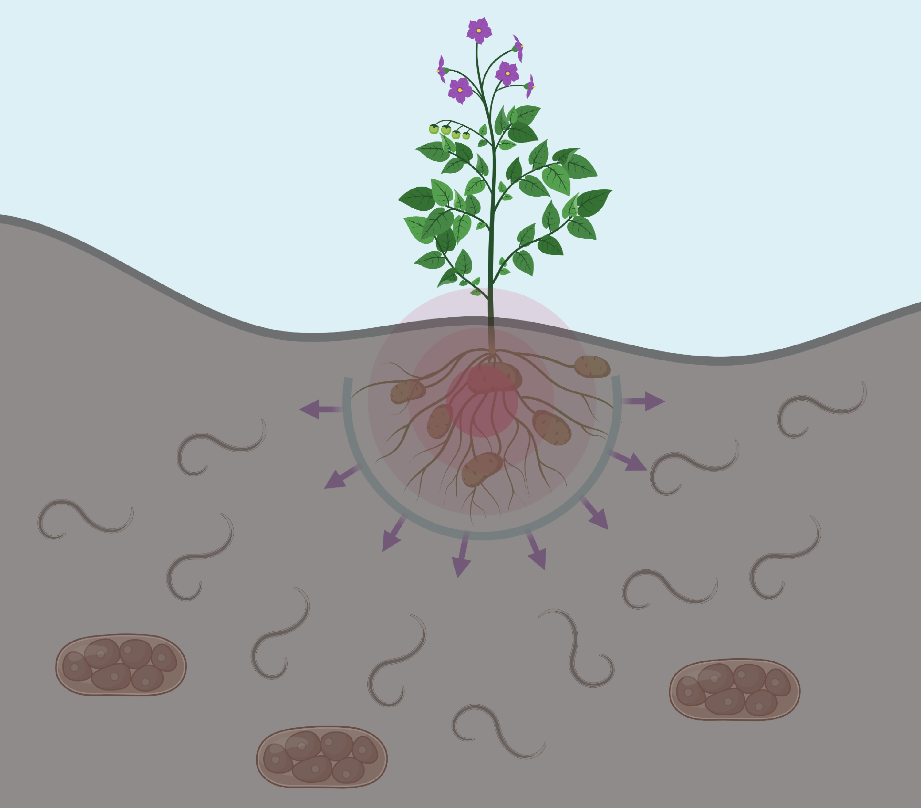
Team GRONINGEN

The problem

The shortage of fresh food and water is more relevant now than ever. The agricultural sector accounts for the big part of food supply in Europe. In particular, potatoes are the most common agricultural crops in the Netherlands. A big loss in the potato yields (est. €460 million in Europe) is caused by potato cyst nematodes (PCN), which can develop harmful syncytia on the roots. These result in the withdrawal of nutrients from the crop and reduced tuber size. Moreover, females of these nematodes form cysts that can survive in the soil for up to 20 years until the environmental conditions are favorable for them to hatch and release 200-300 juvenile nematodes to invade the plant roots again. Farmers mainly deal with this problem by crop rotation and adding nematicides to the soil. It somewhat helps but in some regions the issue is still rather serious.

The goal

As a team of molecular biologists we want to create a product that will help European farmers stay afloat in the current economic conditions. In theory, our product is an easy-to-implement solution that would prevent nematodes from reaching host root while also supporting plant growth. Potatoes are very important crops in the Netherlands and we want to support the sector that produces them for our consumption.

The strategy

This year our team will take on the challenge to protect the roots of potato plants from the nematode parasitism. To achieve it we will design RootPatch, a community of genetically engineered bacteria that will coat the roots and provide the necessary protection. Two bacteria will form RootPatch: B. subtilis and P. fluorescens. The former will produce a short peptide that will enter nematode’s nervous system and reverse their behavior, making them move away from the roots. The latter will produce DAPG, a molecule that facilitates nematode hatching, thus maximizing cyst clearance from the soil.

RootPatch only specifically makes harmful nematodes stay away from the plant, without acting on other soil microorganisms. It also does not spread to the environment or other plants, due to the engineered bacterial dependence on the chemicals produced inside potato roots. In addition, both of them are rhizobacteria and thus facilitate plant growth naturally. In our opinion, using rhizobacteria for crop protection is better than using nematicides that are not spatially contained and can spread far from where they were applied. We hope that RootPatch will ultimately turn the focus from the use chemicals to the more environmentally friendly alternatives.

