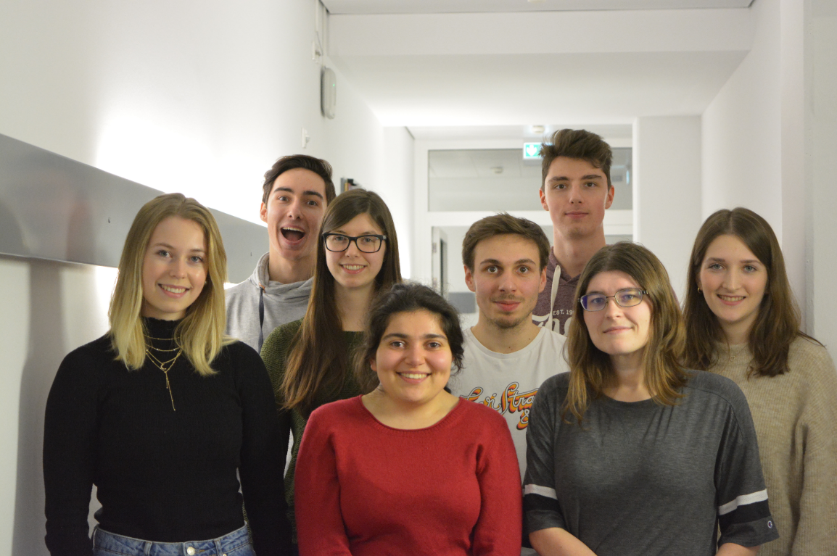

Through open communication and task delegation, our team combines everyone's individual strength, interest, and experience to create a great working atmosphere and team spirit.
We formed our group at the end of 2019. We consist of nine students from the biology, chemistry and physics departments of the Technical University of Kaiserslautern who are passionate about our subjects and the challenges iGEM presents us. Since we are the second iGEM team of our university, as well as in the entirety of Rheinland-Pfalz, our aim is to successfully continue to establish iGEM at the TUK.
Our team is supported by three academic instructors of the departments of Microbiology and Biotechnology.
Prof. Dr. Frankenberg-Dinkel /Professor of Microbiology
Prof. Dr. Schroda / Professor of Molecular Biotechnology and Systems Biology
Jun. Prof. Willmund / Junior Professor of Molecular Genetics of Eukaryotes

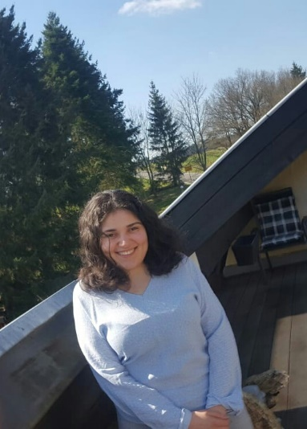
Name: Sarah Abdul-Mawla
Age: 24
Degree Program: Bachelor in Biology
Favorite Laboratory Equipment: Pipette, because you do so much with it
Motivation for iGEM: I wanted to get more practical experience outside the usual uni-stuff and having a choice in the project we create is also great.
Main Responsibilities: Social media, design, sponsoring, and laboratory work

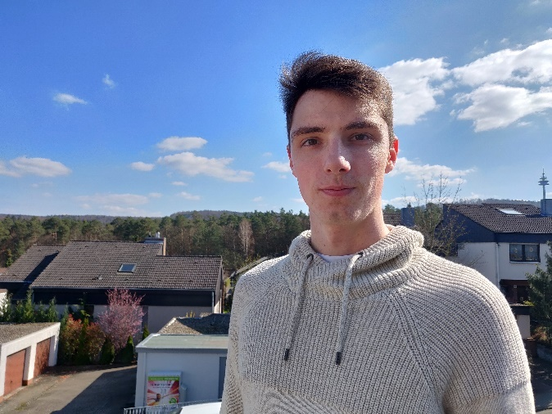
Name: Daniel Brady
Age: 24
Degree Program: Masters in Physics with a focus in theoretical physics
Favorite Laboratory Equipment: Exit
Motivation for iGEM: Offers a great opportunity to learn about webdesign, modeling, and gathering team-working experiences
Main Responsibilities: Design of the website and computer modeling

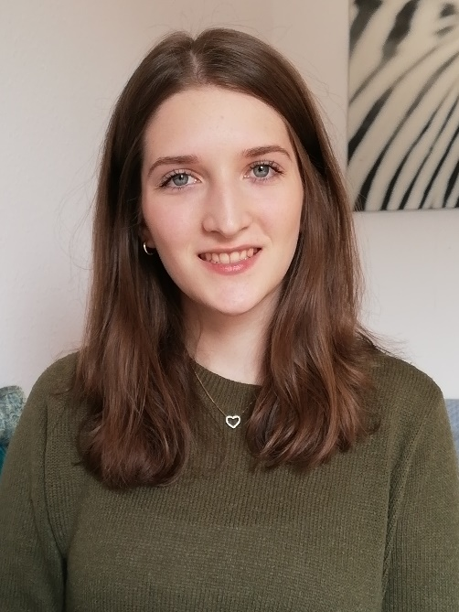
Name: Emily Becker
Age: 22
Degree Program: Bachelor in Biology
Favorite Laboratory Equipment: Centrifuge
Motivation for iGEM: iGEM is a great opportunity to learn to work independently in the laboratory
Main Responsibilities: Laboratory work and sponsoring

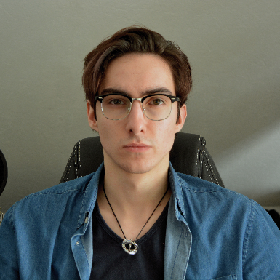
Name: Nicolas Freche
Age: 20
Degree Program: Bachelor in Biology
Favorite Laboratory Equipment: Vortex mixer
Motivation for iGEM: The urge to research and know everything
Main Responsibilities: Social media and design

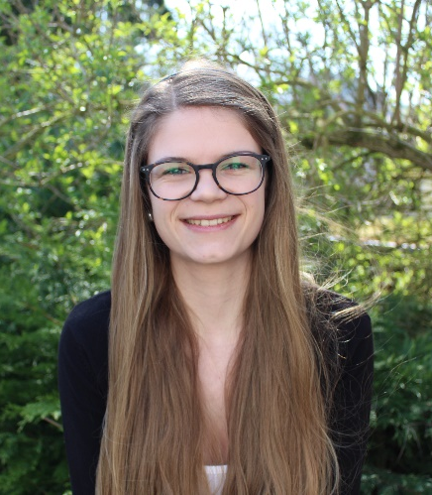
Name: Stefanie Heinrich
Age: 23
Degree Program: Bachelor in Life sciences
Favorite Laboratory Equipment: PIPETBOY
Motivation for iGEM: I hope to gain a lot of experience in the laboratory and to be able to contribute something to this project.
Main Responsibilities: Laboratory work and social media

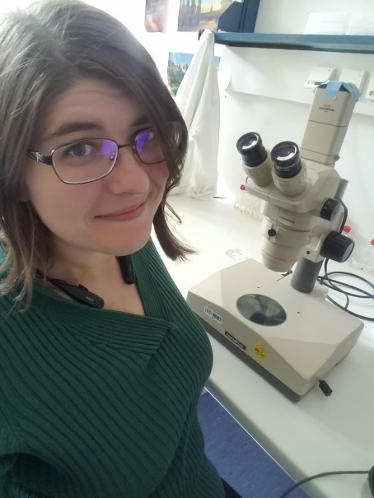
Name: Allyssa Hinkle
Age: 27
Degree Program: Master in Biology with a focus in Ecology
Favorite Laboratory Equipment: Fluorescence microscope
Motivation for iGEM: To learn new techniques in the laboratory and grow my fundamental skills as a scientist
Main Responsibilities: Laboratory work, sponsoring, and English grammar corrections

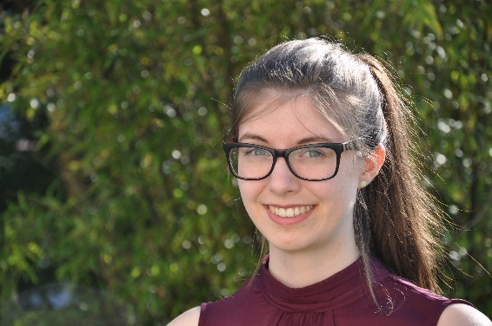
Name: Linda Müller
Alter: 23
Degree Program: Bachelor in Biophysics
Favorite Laboratory Equipment: Photometer
Motivation for iGEM: I am looking forward to working on a project from its conception to its implementation with a nice team and having the opportunity to utilize all the knowledge earned in my studies.
Main Responsibilities: Laboratory work and event organization

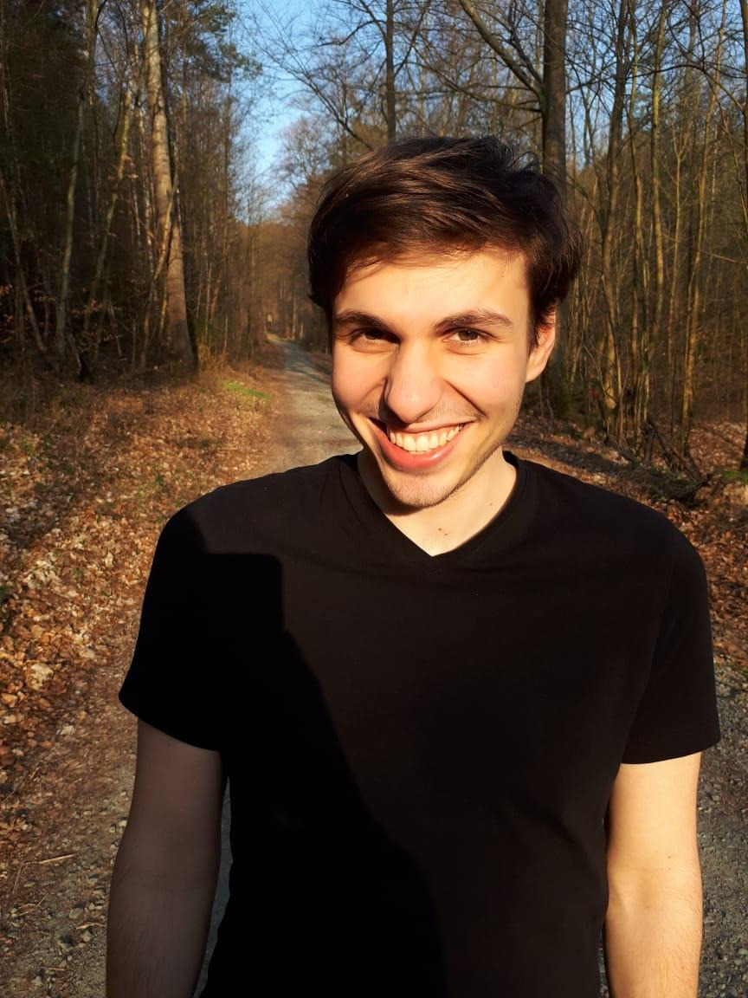
Name: Yannik Schermer
Age: 22
Degree Program: Bachelor in Food Chemistry
Favorite Laboratory Equipment: Soxhlet extractor
Motivation for iGEM: I like the idea of being able to do research with potential real-world application before finishing university.
Main Responsibilities: Event organization and laboratory work

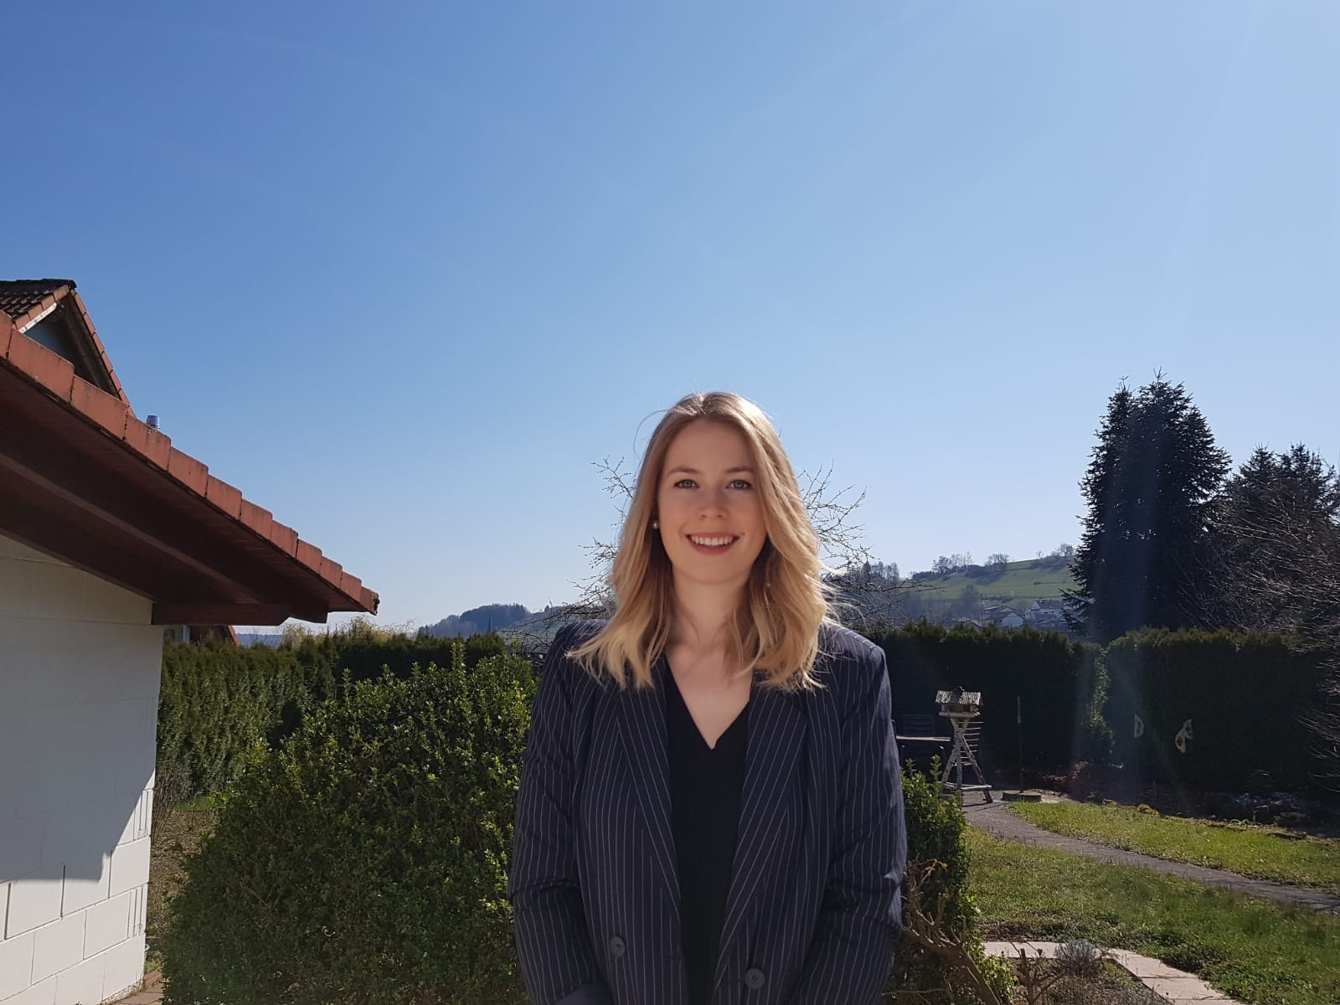
Name: Helena Schäfer
Age: 21
Degree Program: Bachelor in Biology
Favorite Laboratory Equipment: Vortexer
Motivation for iGEM: Through iGEM, I want to improve my lab skills. It is also very important to me to clean our environment from micropollutants in order to maintain the natural and healthy state of the world we live in.
Main Responsibilities: Laboratory work and sponsoring

